# Data source

<https://ourworldindata.org/internet#all-charts-preview>

# Extraction process

## Google chrome

* Open the above using google chrome
* Use incognito mode to avoid cached data
* Right-click and click ‘inspect’
* Go to ‘Network’ tab (not ‘Console’)

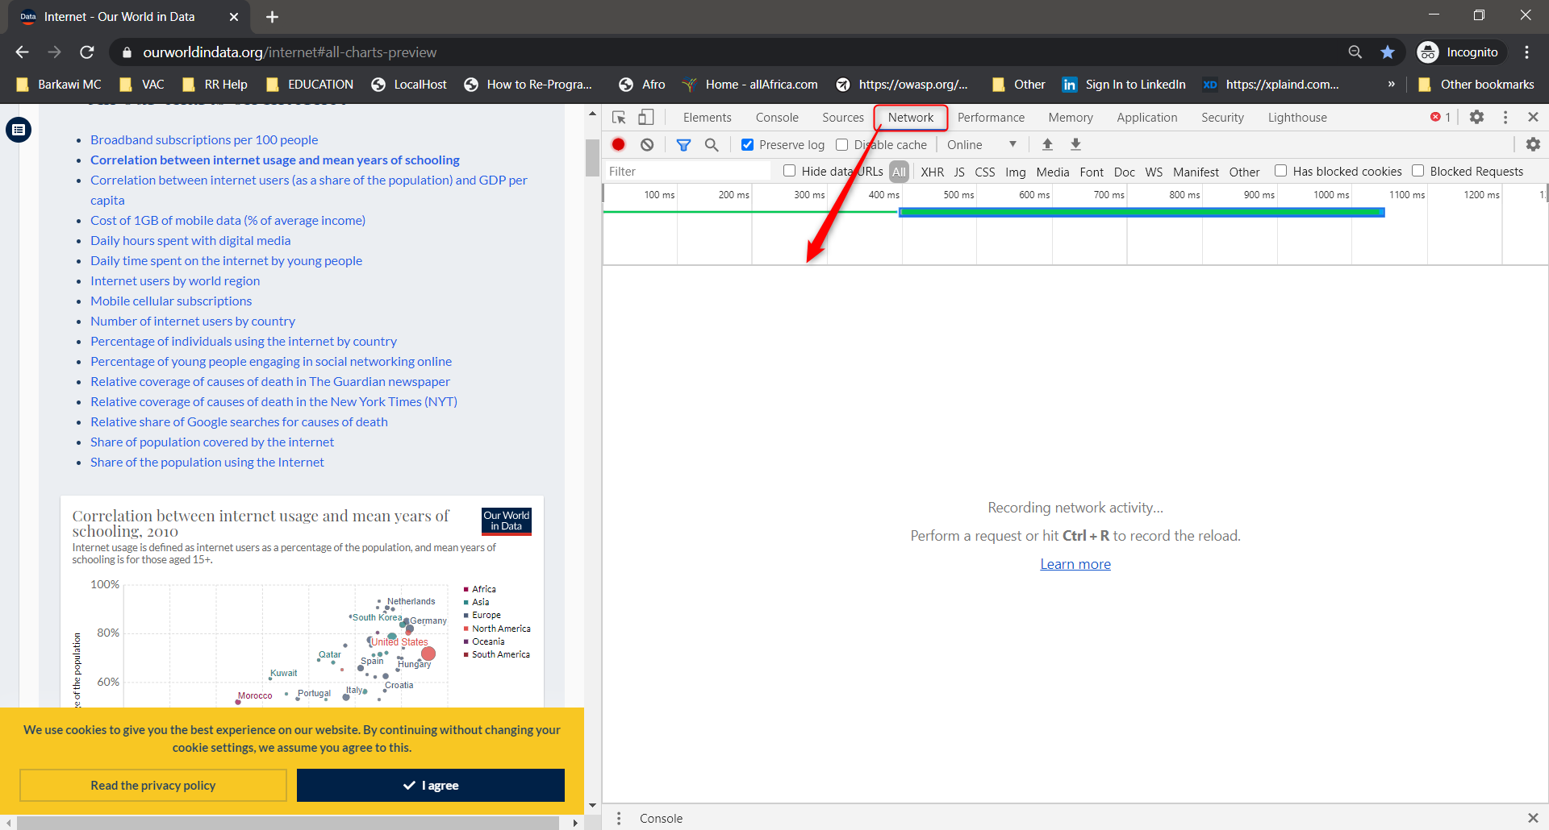

* Check the box called ‘Preserve log’

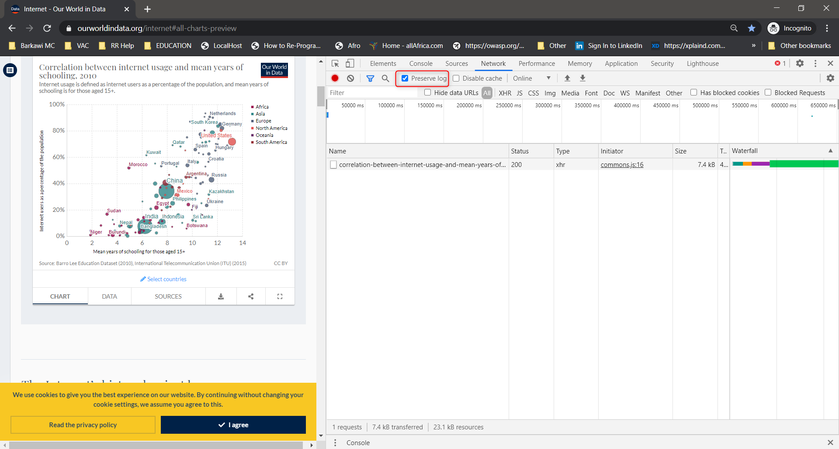

* Click ‘Clear’

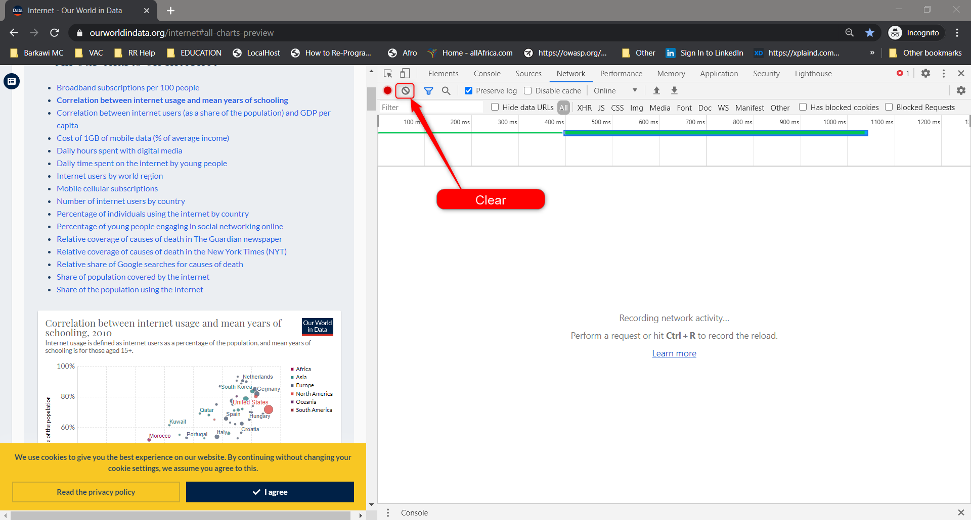

## URLs

* Click the link for the required topic
* The chart is displayed/updated
* Notice on the ‘Network’ tab how 2 new rows were added

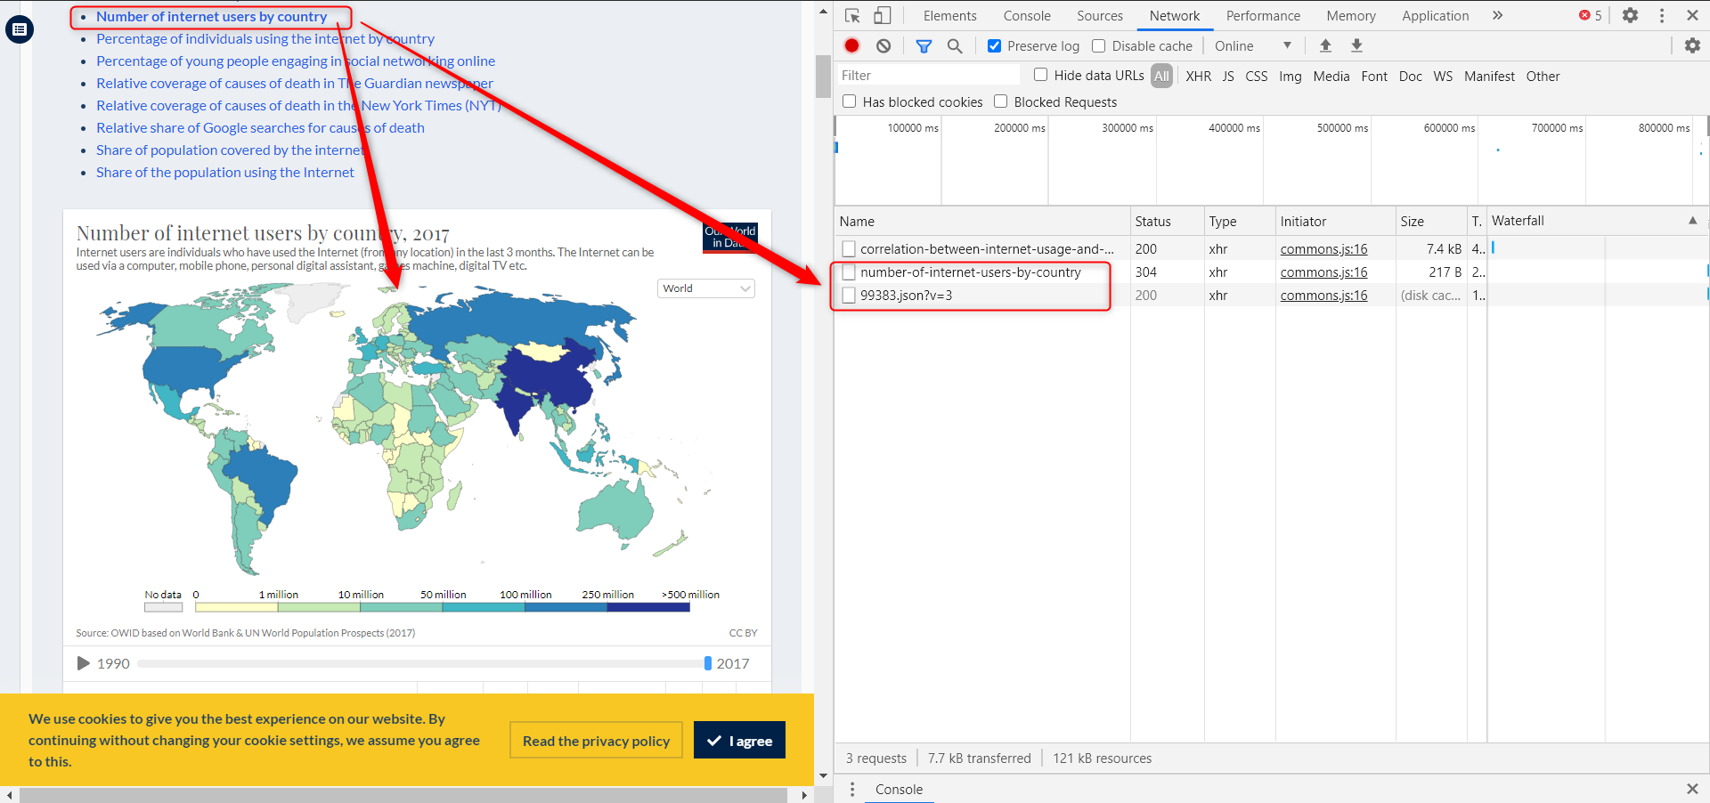

* Click on the ‘.json’ row 🡺 how the data is shown in the ‘Response’ sub-tab

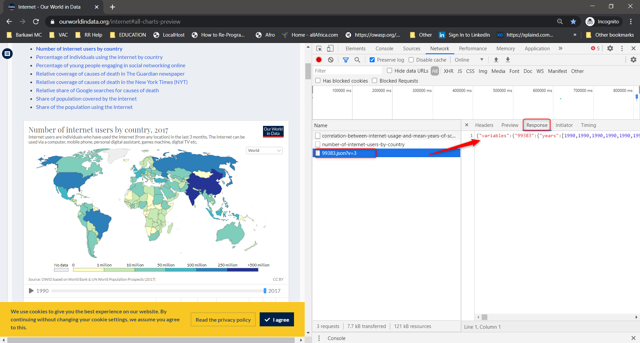

* Click that row 🡺 Notice how the sub-tab ‘Response’ appears and shows data (json format)
  + Right-click the ‘.json’ row
  + Hover over ‘Copy’
  + Click ‘copy link address’

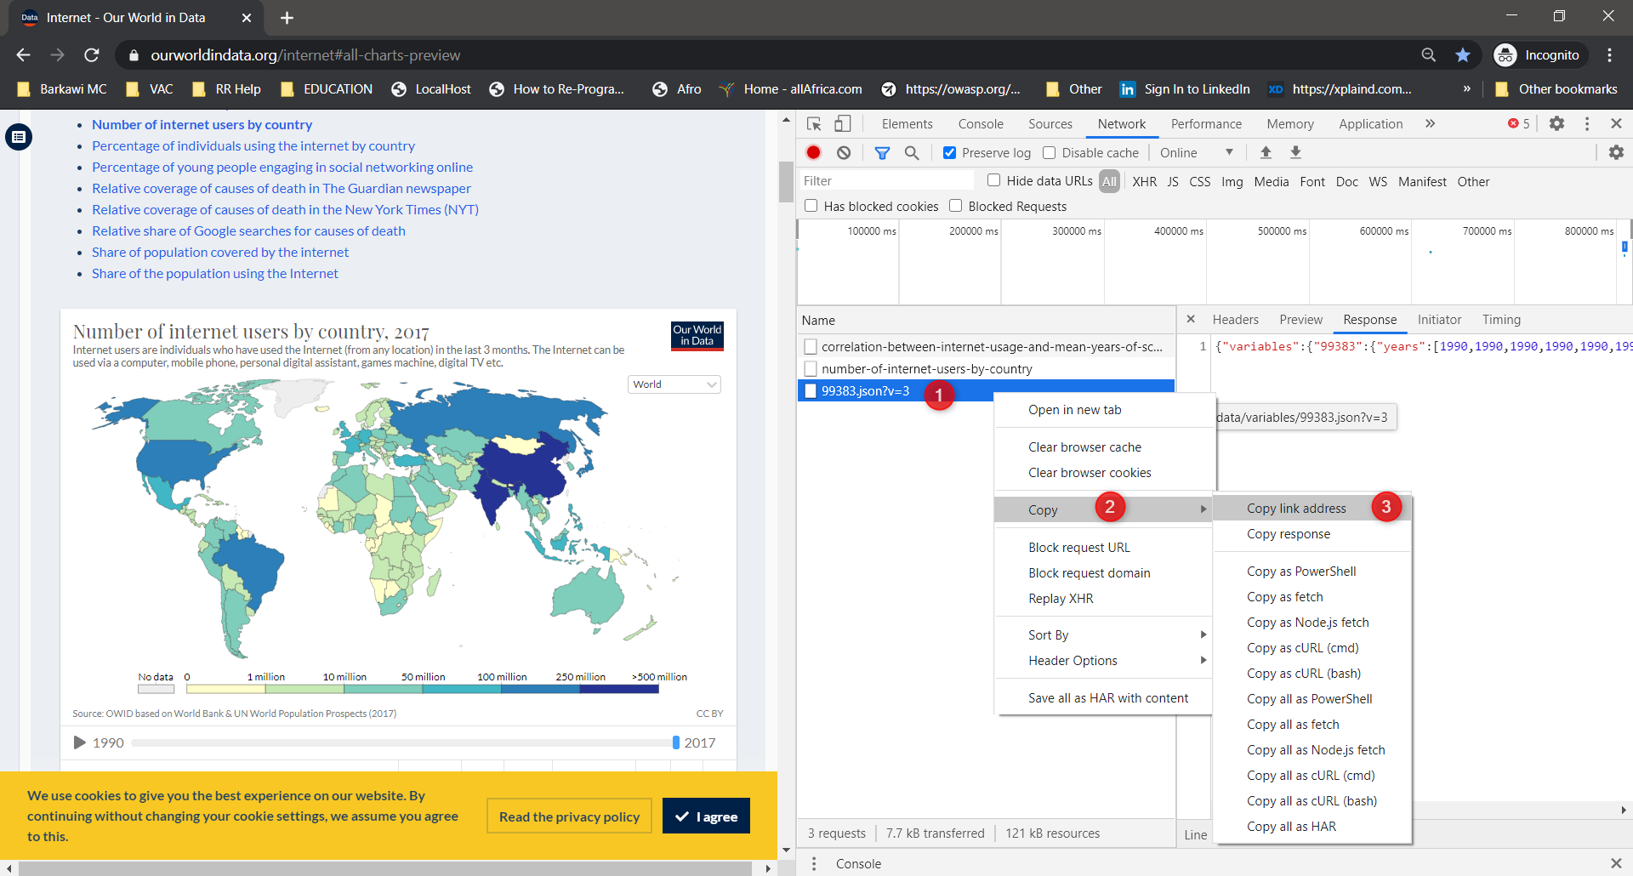

* + Paste the link in Jupyter lab/notebook

## Jupyter lab/notebook (Json requests)

